Andrew Gazin

100207068

CPSC 1181

Assignment 1

Test Plan

|  |  |  |  |
| --- | --- | --- | --- |
| Starting Number/Input | Reason | Expected answer | Actual Answer |
| 3, Easy/ 6, “Okay” | Typical Easy game | 3 | Your number is 3 |
| 4, Intermediate/ 3, “Okay” | Typical Intermediate game | 4 | Your number is 4 |
| 5, Hard/ 25, “Okay” | Typical Hard game | 5 | Your number is 5 |
| -2, Hard/ -73, “Okay” | Negative number | -2 | Your number is -2 |
| 4, Intermediate/3, “Cancel” | Test Cancel Button | No answer | You did not enter a number |
| 4, Intemediate/(blank) “Okay” | Testing blank answer | Error | You did not enter a number |

Picture of it working:

I picked the Negative number example

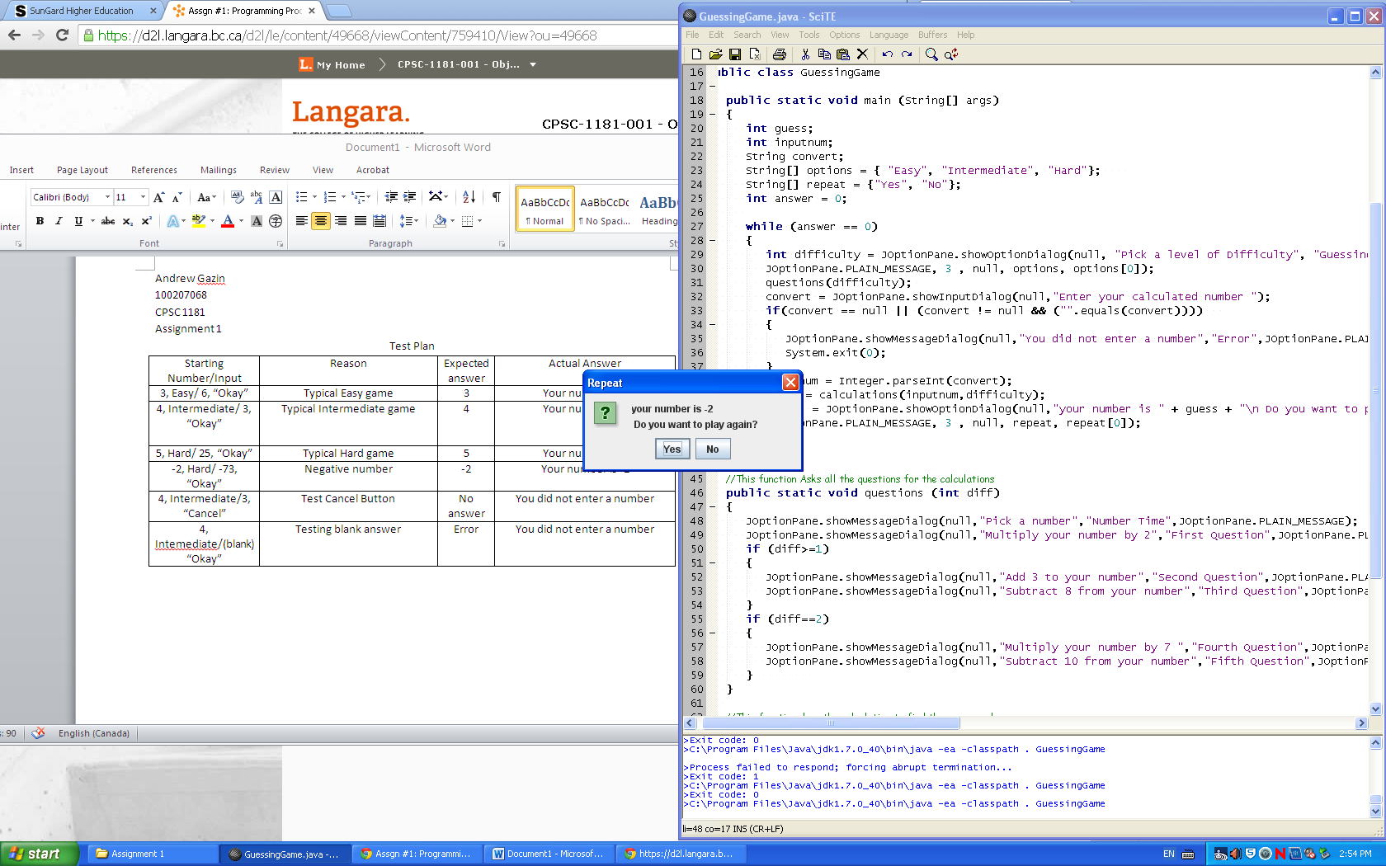

Differences between expected and actual answer:

The only differences were for the error prompt. If they clicked okay but did not enter anything the correct response is they didn’t enter a number. If they type in their answer but click cancel, they did not enter the number, they actually cancelled so they didn’t enter a number.